1.Introduction 2
Getting started 2
Configuration 2
First commands 3
2.Commit changes to local repository 4
3.Commit History 4
4.Undoing things 5
Modifying last commit 5
Unstage a file before a commit 5
Unmodifying a modified file before a commit 5
Cancel commit and more 5
Cancel commit only 6
5.Publishing code 8
6.Branches 8
Local branches 9
Create branch and changing branch 9
Merge Changes 9
Stashing code before toggle to another branch 11
Creating branch on remote server an tracking from local 11
To stop tracking a remote branch 12
To delete remote branch 12
7.To tag a version 13
8.Avoiding commiting particular files 13
9.Short summary of useful commands 14
To merge branch 14
10.Other 14
Git add 14

Introduction

Git is a distributed revision control systems based on server. Every developer holds release history, server is a meeting point

Getting started

First you have to be registered on this project using redmine
https://opensource.umr-cnrm.fr/

Check if you already have a ssh key in $home/.ssh directory and send it to operator@meteo.fr

If not, create one using following command : ssh-keygen , don’t set password
Send .pub file to operator@meteo.fr

Create a directory for your project (e.g. $HOME/SURFEX_GIT )

Configuration

You can set git environment colors to better readability like this

$ git config --global color.diff auto

or opening the git config file and set variables like that
gedit ~/.gitconfig

[color]
diff = auto
status = auto
branch = auto
[user]
name = myname
email = me@email.com
[alias]
ci = commit
co = checkout
st = status
br = branch

Alias are used to shorten command ex: git st =git status

Get the latest version from the server :

$ git clone ssh://admin049@git.cnrm-game-meteo.fr/git/surfex.git if you have R/W access

$ git clone ssh://reader049@git.cnrm-game-meteo.fr/git/surfex.git if you have R access

git clone is done once to download all repository.
For new update make
$ git pull which is equivalent to
$ git fetch to verify everything is up-to-date
then $ git merge merge new code
Get the code from the 7.1 tagged release :

$ git checkout <tag_name> -b <branch_name>

$ git checkout tags/v7.1 –b tagv7.1 get v7.1 tagged code to local tagv7.1 branch
$ git checkout tags/v7.1 get v7.1 tagged code in detached head mode
can be named then using :
$ git checkout -b newbranchname
List of tags is obtained with $ git tag -l

First commands

Git status give the state of files

Files can be tracked or untracked , when tracked there is 3 states unmodified , modified , staged for next commit.

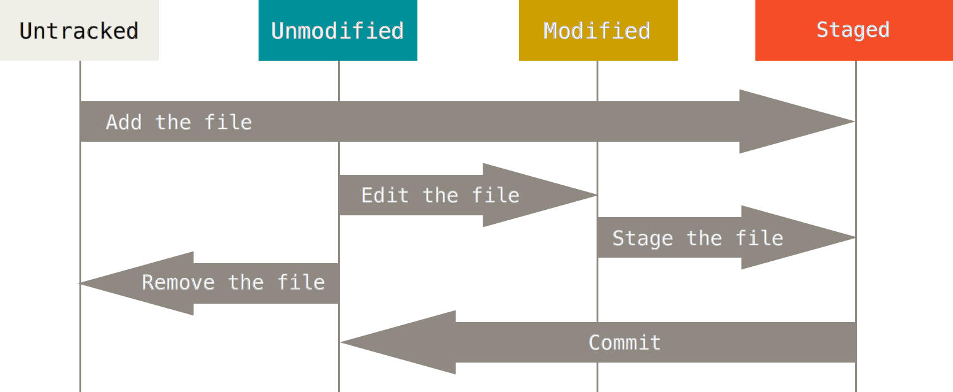

If you create a new file or modify an existing file form a previous commit it is still tracked but you have to staged them using ‘add’ before committing

Add function has two roles : adding untracked files , staging modified tracked files for next commit

In green, appears files staged for committed, following files needed an ’add to be staged’ and last untracked files

For example you add config.ini to working directory and done a git add config.ini, result of git status is :

$ git status
On branch master
Changes to be committed:
(use "git reset HEAD <file>..." to unstage)

new file: config.ini

Changes not staged for commit:
(use "git add <file>..." to update what will be committed)
(use "git checkout -- <file>..." to discard changes in working directory)

modified: file.F90

Untracked files:
(use "git add <file>..." to include in what will be committed)

readme.txt

There is 3 more options to add files

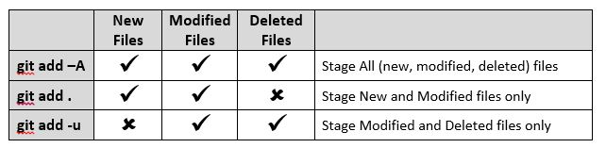

Once add done you can see differences more precisely from last commit using diff

git diff : git status + display changes since last commit of non staged files
git diff --staged : git status + display since last commit of staged files only
git diff HEAD : git status + display since last commit of staged and non staged files

added lines are preceded by “+” deleted by “-“

If changes suit you, you can now run a commit

Commit changes to local repository

You can use git commit without option , so a text will appear letting you adding comments to record for this commit ( needed )

To avoid this editor step you can simply use –m option :

$ git commit –m ‘ comment on changes ‘ to commit staged files only
$ git commit –a –m ‘ comment on changes ‘ to commit all staged and modified files
$ git commit –m ‘ comment on changes ‘ file1, file2 to commit specific files

A commit is local to your PC no one knows changes you made before you publish , that gives you the opportunity to make changes if you realize you made an error.

In case you made an unwanted commit you can go back : $ git reset --soft HEAD~1

Compare file from two release

$ git diff HEAD^ HEAD txt5.txt compare txt5.txt between current and previous
$ git diff HEAD^^ HEAD txt5.txt compare txt5.txt between current and 2 commit back

Commit History

Every commit is identified with a hash number

To see all that appends use the log command to see more information relative to each commit, author, id hash, comments …

$ git log
$ git log --stat for a short history
$ git log -p to see add and removed lines , display all differences between stages
*added lines are preceded by “+” deleted by “-“

A useful one presenting hash, author, date and comment

$ git log --pretty=format:"%h - %an, %ar : %s"

Have a look at git-scm.com Ch 2 sect3 to see all possibilities

Undoing things

Modifying last commit

If you want to modify the last commit message or you forgot to add a file, proceed as following

$ git commit -m 'initial comment' ( message with an error )
then
$ git add forgotten files
$ git commit -m ‘new comment’ –amend

There is no new commit this one replace the previous one

Unstage a file before a commit

If you wrongly add a file you can unstaged it using:

$ git reset HEAD filename

Unmodifying a modified file before a commit

$ git checkout modfile

! Every changes you made to modfile are gone, you overwrite it with version from last commit

Cancel commit and more
See following picture to note different kinds of cancellation
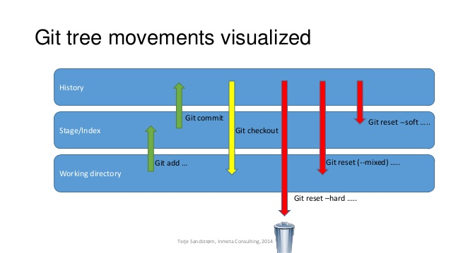

Soft reset : undo commit only
Hard reset : undo commit an staged step and files modifications, all changes are lost since last commit
Mixed reset : undo commit and staged files, without explicit mode, mixed is default one

Cancel commit only

To cancel last commit
$ git reset --soft HEAD^1

To precise witch commit you want to go back to there is several way

With number of backward step

cancel last commit HEAD^1,
cancel last commit but 2 HEAD^2 …

With Sha id

use $ git log to get commit you want to go back to, then
$ git reset e9d8241 for example

Git keeps a log of all ref updates (e.g., checkout, reset, commit, merge).

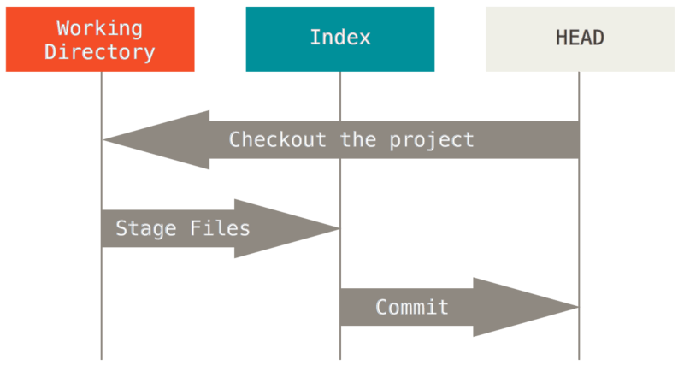

$ git log to list all commit Id

and use $ git revert e9d8241

use $ git log to see last commits and the one you want to return to

Reset can also be canceled à réécrire !

Use git reflog to list all last actions

To undo git reset HEAD
$ git reset HEAD@{1}

Use reflog to see each index of commit, so you can go back to index you want , note that reflog is not infinite ( about 1 month )

Publishing code

Everything done until now was in local mode, this time you want to share your code with other users. Check your code that after this step you cannot cancel your commits.

To avoid conflicts its needed that nobody make a push just before you, anyway if push fail you’ll be invited to make a pull first to be up-to-date

$ git push

It is recommended to commit every time a little step is done, but you should use push with parsimony.
Push are irreversible, so you lose the flexibility of canceling or modifying commits flexibility of GIT

Although it is not recommended regarding the work flow but it ‘s still possible to cancel it or rather to make a new commit reversing modification.

Refer to git log that give you history of project:

commit 11e6631765d3bc7548de93071e5d3698bec0c8dc
Author: sebastien_DASPREZ <sebastien.dasprez@meteo.fr>
Date: Wed Jun 3 16:22:38 2015 +0200

mod txt2 to br22

commit 58ecf538a8346a6e8a617bbf10d279e177aca631
Author: sebastien_DASPREZ <sebastien.dasprez@meteo.fr>
Date: Wed Apr 1 18:48:28 2015 +0200

Tempe.doc correction

Use $ git revert 58ecf to cancel it ,this will create a new commit , you can now make a push to publish this modification. Sha is unique so using first digits is sufficient

Branches
Create new branch
*
Merge with master
*

Master
(main branch )

Commit
Commit
Commit
Commit

records management
Create
Commit
Commit
Commit

Global management

Commit

The main asset of git is managing branches. I.E you can work on project developing functionality in parallel. So you can test ideas before integrating them to master branch.

For example you can create a branch to manage files record in various way because it take time you cannot integrate this modifications to project immediately. Moreover you can create a sub branch from a branch to test a specific management. In that case this last idea does not succeed so it has been cancelled.

Local branches

To see all branches in your project use

$ git branch

If you just started the project only one branch appears, there is a star in front of current branch

*master

Create a branch every time a modification is not a quickly one, in the worst case you created one for nothing but it’s better that way than vice versa.

Create branch and changing branch

In the case you want to create a new branch “record options” to enhance record possibilities

The command is
$ git branch record_options

You can see it with $ git branch

*master
record_options

Your always on master branch , to toggle to the new one use :

$ git checkout record_options

Checkout has a double use. To change branch and to recover a file as it was before last commit

$ git checkout -b prob53 -create branch & switch to prob53

Merge Changes

When you think that code can be integrated to master branch you can add it with merge command.

Go to the main branch , master in this case but it can be any else

$ git checkout master

Then add code developed in record_options with

$ git merge record_options

record_options branch can now be deleted.

$ git branch –d record_options

git will check before deleting the branch that it has been merged previously if not it doesn’t allow deletion. If you want to coerce deletion use $ git branch –D record_options

Stashing code before toggle to another branch

You might want to toggle to another branch to modify code while you are working your current branch.

But if you change of branch files are lost if you don’t do a commit.
stash
Modifications of working directory
Stash apply
Working on my branch
Working on master
Commiting modifications
Commiting modifications
Checkout master
Checkout mybranch
To toggle to another branch git status has to be clear i.e git status hasn’t to return modifications.

To avoid committing unnecessarily you can use stash command :
files are stored but not commited, you can do something else. When going back up to your initial branch, files are restore with stash apply, you can then resume your work with those files.

Creating branch on remote server an tracking from local

A ) Directly on serveur

Creation of the remote branch on server
$ git push origin origin:refs/heads/newbranch

then creating local branch from remote branch
$ git checkout --track origin/newbranch

This last command will create a local branch of same name tracking remote branch

To create a local branch tracking a remote branch with a different name :
$ git checkout -b foo --track origin/branch
$ git checkout -b foo origin/branch
Create foo local branch switch to it and track origin/branch

B) from local branch

creation of local branch $ git branch newbranch
toggle to local branch $ git checkout newbranch
or in one command $ git checkout -b newbranch
creation of remote branch from local $ git push -u origin newbranch
creation of remote with a different name from local $ git push -u origin newbranch:rmnewbranch

After last command local branch will track remote branch
Do not make the critical mistake of specifying only :<remote-branch-name> (with the colon), or the remote branch will be deleted!

C) Tracking remote branches

for an existing local branch foo:
$ git branch -u origin/newbranch06 foo

To create a local branch form a remote with same name:
$ git checkout --track origin/newbranch

To create a local branch from a remote with a different name :
$ git branch --track branch-name origin/branch-name

To stop tracking a remote branch

Go to the concerned local branch then
$ git branch --unset-upstream

To delete remote branch

$ git push origin --delete remotebranch
or
$ git branch -r -d remote branch

To tag a version

Tagging a version is usefull to reference a particular commit and facilitates identification for other users.

In the current branch just after a commit you can tag a version with command :

$ git tag tag_name

if it a previous commit

$ git tag -a tag_name part_of _id ( sha )

to tag with a tag message

$ git tag –a tag_name – m ’tag_message’ ‘q’ to exit ?

Later

get the Idcommit with git log command or using redmine viewer ??????????

ex :git log --pretty=oneline

git tag -a tag_name –m 'message' part_of _id ( sha ) / tag with message

For example

git tag -a v1.3 2f7c8b3428aca535fdc970feeb4c09efa33d809e
git tag -a v1.2 -m 'version 1.2' 9fceb02

then
git push –tags
to send ag to server

git show give the sha of current branch

tags are not automatically sent during a push you have to push it specifically

$ git tag –tags

to delete a delete use

$ git tag –d tag_name

Avoiding committing particular files

After running code to ignore some results files or documentation
Create a .gitignore file in root and write files, directory or regexp to ignore one file per line

*.tmp
tmpdir/*
directory/temp.txt

It is useful with temporary files for example or data files that is not needed to save.

Short summary of useful commands

other git commands

git branch -d branch delete branch
git branch -D branch force delete branch without managing recorded files
git branch -r -d origin/ branch delete branch from the server

git branch –r list server branches
git branch list existing branches , * notifies the current one

git branch -vv list of local branches tracking remote branches

git tag list existing tags

git checkout tag -b branch_name get tagged version into branch

git diff src/Symfony/Components/Yaml/Yaml.php

git pull update from server
git fetch to verify everything is up to date
git checkout file_name cancel file modifications, get file as it was on last commit

To merge branch

Branch can be merge in master or in any other branch

checkout « parent_branch » go to “parent” branch
git merge branch merge branch in parent_branch

Other

git status List which files are staged or tracked

git add file1 file2 or path include a new file for next commit
or include a modified file for next commit
git add it used to add a file to track if it’s new or to be add to next commit if modified or after a conflict resolution <<<<<<>>>>

Git add

git remote (-v) list names of registered servers (show url)

git reset HEAD file unstage, cancel a git add before a commit
git reset file short command
need to be in the directory

git log view history
git log –p view detailed history

git commit --amend -m 'correction' change previous message by correction

undo last commit

git reset --soft HEAD~1 undo last commit

git checkout file recover file as it was from last commit

$ git checkout v7.1 get v7.1 in detached head mode !!!!

Site to consult

https://git-scm.com/book/fr/v2

________________________________

when file are different merge can be

git mergetool mld

